Franklin Technology Center
Course Syllabus

Campus: 420 Grand Ave

Department: Welding (417)-625-5260 ext. 3216

Course Title: Welding Technology

Course No.: 172306

Program Type: Secondary

Credit: 3 Credit Hours

Prepared By: Dave Noah, Welding Instructor
e-mail: dnoah@joplin.k12.mo.us

Date Approved by Department: 6/1/2012

Assistant Director: 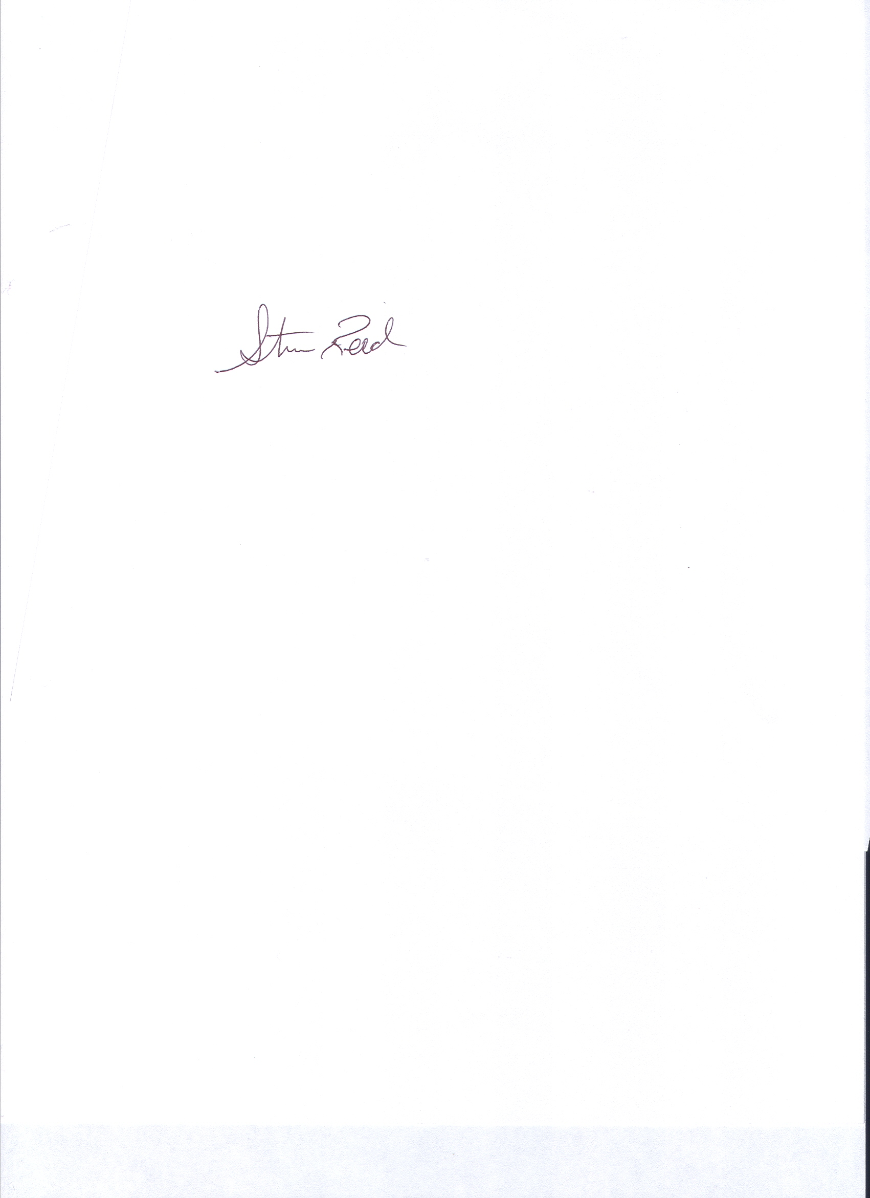

- Course Description for Catalog:

Welding is a two-year vocational program that meets in a three-hour block and offers three units of credit per year. This program is designed so the student can become employable as an entry-level welding upon successful completion of the course.
The welding skills required by industry, as well as related technical information, are offered so the students; performance meets the needs of industry. The common welding processes of oxy-acetylene, electric arc, tungsten inert gas and metal inert gas welding on various types of metal sand positions are taught, as well as plasma cutting and pipe welding. Related technical information on shop safety, the proper use of hand tools, shop math, measurement, lay-out and print reading is all important aspects of the welding program. The class time consists of one period each day in the classroom and two periods in the shop. Student progress is achieved on an individual basis. Shop jobs such as school projects are a requirement for advanced students
Students are required to provide their own appropriate work clothes, shoes, and eye protection. Franklin Technical Center provided the necessary tools and equipment that meets the standards required by industry.

- Objectives of the Discipline:

By actively participating in this course and successfully completing all assigments, the student will:.
    - Students will be trained for entry-level welding positions
    - Students will have opportunity to use most up to date equipment
    - Students can obtain OSHA 10 safety certificate
    - Students will have opportunity to take and pass an AWS D1.1. weld test

- Course Outline:
Year One: Safety, Oxy-Acetelyne welding, Shielded Metal-Arc welding, blueprint reading, layout

Year Two: Gas Metal Arc, Gas Tungsten Arc. Plasma Cutting, Pipe Welding

The Learner will:
    - Identify and practice basic safety in welding. (3.1, 3.2, 3.3, .3.4, 4.7
    - Be able to identify basic blue prints. (1.5, 1.10, 2.1, 2.5, 2.6
    - Be able to layout plate and structural material to entry-level standards.(1.10, 2.1, 4.6)
    - Cut and weld with oxy-acetylene welding equipment. (1.10, 2.5, 3.2, 3.4, 4.7)
    - Weld with shielded metal arc welding equipment (1.10, 2.4, 2.5, 4.7)

    - Weld with gas metal arc welding equipment. (1.10, 2.5, 3.1, 3.2, 3.3, 3.4).

    - Weld with gas tungsten arc welding equipment. (1.10, 2.1, 2.5, 3.6, 3.1, 3.2, 3.3, 3.4)

    - Cut with plasma cutting equipment. (1.10, 2.5, 3.5, 4.1)

    - Identify different types of material (1.10, 2.5, 4.7)

    - Participate and understand SkillsUSA and its purpose. (2.1, 2.2, 2.3, 2.7, 4.2, 4.3, 4.3, 3.5, 4.6, 4.8

- tEXTBOOKS: Modern Welding text by Goodheart Wilcox

- WEB-SITE: http://ftcwelding.weebly.com/

- Daily Procedure

Class rules:

1.Be in your seat and quiet before the tardy bell rings.
2.No hats worn in the classroom.
3.Any refusal of teachers orders will result in an automatic trip to the office.
4Always wear safety glasses in the shop area.
5.Bring notebooks, paper and pencils (or pens) to class every day unless notified.
6.Do not move from one type of welding to another without teacher permission.
7.Do not bring any project into the shop or class without teacher permission.
8.Each student is given one pair of gloves and one set of safety glasses by FTC. You are to have these each day that you are in the shop. If the gloves or glasses are lost, stolen, or otherwise destroyed, the replacement cost for both these items will be responsibility of the student.
9.Students are to bring their own pliers to FTC and have them everyday that we are in the shop. Students neglecting to do this will spend their time in the classroom writing a report for me and a zero for the day will be given
10.Students ware required to bring their own:
  - Coveralls,
  - Boots (at least 6” tall)
  - Some kind of pliers,

REQUIRED COST FOR THIS PROGRAM:

- Skills u.s.a. dues $15.00
- skills u.s.a. fall leadership $5.00 (if applicable)
- skills u.s.a. district competition $12.oo (if applicable)
- nths $25.00 (if accplicable)

- CLASSROOM RULES, RESPONSIBILITIES AND EXPECTATION
All rules per Franklin Technology Center handbook apply in class. Instructor may add policies or rules as needed to insure good order and safety in classrooms and labs, like the following:

- To behave in a professional and respectful manner, be punctual, prepared with textbook, writing utensil, any assigned work, a separate notebook for note-taking, and ready to learn upon entering the classroom.
- To share in the excitement of learning about the health care world.
- To participate in classroom discussions, group activities, and projects.
- To always look for opportunities to learn, be useful of in class time, and stay on task.
- To seek individualized instruction when needed.
- To prepare assignments, notebooks, and other projects neatly, legible, and turn them in on time.
- To maintain an open mind, be respectful of others, and their differences.
- To work as a community within the classroom and help fellow students.
- No food or drink in the classroom, and students will be given water and restroom breaks on a regular schedule.
- Student expected to request missing work upon returning from an absence.

- Evaluation & GRADING:
Grades will be based on exams, quizzes, homework, class notebook, special projects/presentations, participation, etc.

Grades will be based on TOTAL POINTS EARNED/TOTAL POINTS POSSIBLE.

Students are expected to keep track of their own grade. A table has been provided by the instructor for this purpose.

Accumulative Grade Percentage with maximum days of unexcused absents
A - 100-90% Maximum if absent 4 days
B - 89-80% Maximum if absent 5-6 days
C - 79-70% Maximum if absent 7-8 days
D - 69-60% Maximum if absent 9 days
F - 59 – 0% Maximum if absent 10 or more days

All grades in this course of study are based on a weighted percentage system. There are 5 aspects to this course, which determines the weights of the system. This system is in effect so that an individual cannot pass this course by relying on one aspect alone. The percentages are as follows:

1. Daily Participation Grade/ Work Ethic 50%
2. Notebook (classroom including Math & English) 10%
3. Lab Tests 30%
4. ClassroomTests/Exams 10%
Semester Grade 100%

On the grade card there will be placed a letter grade of A, B, C, D, F to indicate the grade achieved during the grading period. Each student will receive a Student Profile indicating which tasks have been mastered during the course of the two year program. A certificate will be given only after completion of the course with a minimum average grade of a C and at least 90% attendance. Employability readiness is directly related with the grade achieved and the tasks mastered

Days absent can be made up by attending scheduled OPEN SHOP after school times, or computer web based assignments given by Mr. Noah

Elements of your Grade

PARTICIPATION GRADE and/or WORK ETHIC 50%
This is an essential element of a career and technical course. It involves tardiness, absenteeism, work habits and attitude, proper care and use of equipment and work areas, treatment of fellow classmates and instructor. Each student will receive 40 points daily. However, points will be subtracted from the listed areas:
Attendance / Punctuality 10 points
Safety / Horseplay 10 points
Lab participation/Clean-up 10 pts.
Violation of class/school rules 10 pts.

NOTEBOOK/CLASS WORK 10%
Journal, papers, syllabus, class/shop rules, charts.
Math & English assignments will be assigned a point value
LAB / PROJECT GRADE 30%
Labs and projects will be assigned a point value

TEST GRADES 10%
Test may be on paper, in lab, or combination of both
Test may not be made up due to an unexcused absence.

- Attendence
Important:
Franklin Tech is modeled after the workplace, in this welding program students are expected to be in class and on time every day. Personal business must be taken care of on your own time. Approved school functions are the only excused absences. ALL other absences other than school functions are unexcused. Dr. appointments, illness, funerals etc. are all days absent. In the educational process, if instructions and training opportunities are missed, it will be reflected in the points received by that student and will affect their grade as follows:
Students can call Mr. Noah at Franklin Technology center phone, Mr. Noah’s cell phone, e-mail instructor and receive half of daily points.

Late Work:
Late work is unacceptable in the work place. One of the essential skills to be obtained during this course is the ability to meet deadlines. Of course there are exceptions for absences due to illness and school related activities. It is the student’s responsibility to seek missed assignments. Instructors are not obliged to repeat a lab of other in-class experiences missed by the absent student. Students should be aware that the quality of learning experience may suffer as a result of absence and/or chronic lateness. There will be a penalty of one letter grade (10%) for each day an assignment is late up to 3 days. Therefore the following penalties will be assigned for work turned in late:

1 DAY -- 10% Reduction in Grade
2 DAYS -- 20% Reduction in Grade
3 DAYS -- 30% Reduction in Grade
4 DAYS or more -- NO GRADE

A student can miss anywhere between 1 – 4 days and keep their A. Miss 5-6 days absent and you automatically fall to a B. Then if you miss as many as 7-8 you can expect a grade of a C. Miss 9 days, drop to a D. ANYTHING over 10 days will result in grade of an F for the semester.

EXCESSIVE LATE WORK WILL NOT BE TOLERATED. A CONFERENCE WITH PARENTS/GUARDIANS AND/OR PRINCIPAL WILL RESULT.

WARNING!!!: ANY STUDENT PLAYING GAMES ON THE COMPUTER OR UNAUTHORIZED USE OF THE INTERNET, DURING CLASS HOURS WILL RECEIVE A ZERO FOR THE DAYS WORK ETHIC AND A ZERO ON THAT DAYS ASSIGNMENT.

ABSENCES:
It is the student’s responsibility to follow up on missed work, tests, notes, etc. This should be taken care of at the beginning or the end of regular class time. The instructor can be available before and after school, however the student is responsible for making arrangements with the instructor).

Tests: Advance notice will normally be given preceding an exam/test.
Quizzes: No advance notice.
Absences on exam day: The exam should be made up within 1-2 days of the absence.
Absent the day before an exam: The student is still expected to take the exam on the date scheduled.
School Related Absences: It is the student’s obligation to turn in assignments, take exams/quizzes, and complete other class duties before leaving. Failure to do so may result in a reduced grade or a 0%. Good rule of thumb: always check with the instructor when you know you’re going to be absent.
Quizzes cannot be made up:

Parents will be notified at each absence:
I believe that education is a partnership between students, educators and parents.
Parents have a right to be informed in the student’s progress,
or lack of progress in the student’s development

Days absent can be made up thirty minutes before or after school or on teacher identified days. 120 minutes required for 1 day of make up.

Attendance: (Joplin R-VIII Board Policy amended 7-25-95) students who accumulate ten (10) absences during a semester may lose credit and be dropped from school. Absolutely no make up assignments will be given or accepted after the 10th absence, this includes tests and quizzes.

Academic Honesty:
Consistent with the Joplin Schools policy and simply stated, every student is expected to complete his/her own work. Per the school district policy, students who participate in any act which would deceive, cheat, or defraud to promote or enhance their or anyone else’s grade or grades has committed academic dishonesty. Academic dishonest also includes knowingly or assisting other people committing academic honesty. Academic dishonesty includes but is not limited to plagiarism (using other people’s work for their own) or cheating in any form. If this policy is violated all parties involved will receive a zero for that assignment.

CLOTHING POLICY
One of our top priorities at Franklin Technology Center is to train the student to successfully enter and to succeed in their chosen field. Students will be expected to dress appropriately for their career path. Hats, if worn, MUST BE REMOVED UPON ENTERING THE BUILDING AND REMAIN OFF WHILE IN THE HALLWAYS WITHOUT REMINDERS, UNTIL THE STUDENT EXITS THE BUILDING. Some programs allow hats in their lab areas.

A POLICY OF NONDISCRIMINATION: The School District of Joplin R-VIII and Franklin Technology Center complies with all local, state, and federal laws and regulations concerning civil and human rights. Educational programs, admissions, and employment practices of the school district and school are free of any discrimination based on race, sex, color, religion, national origin, handicap or prior Vietnam or military service. The policy of the school district and school not to discriminate on the basis of sex or handicap is in compliance with Title IV of the 1972 Educational Amendments, and Section 504 of the Rehabilitation Act of 1973 respectively.

Compliance Officer:
Superintendent of Schools
The School District of Joplin R-VIII
P.O. Box 128
Joplin, MO 64802
417-625-5200

It is the policy of Franklin Technology Center not to discriminate on the basis of race, color, age, gender, disability, religion, or national origin in its education programs, financial aids, activities, admission, or employment policies.

Under the Americans with Disabilities Act, every effort will be made to assist any student with special needs. If you are an individual with a disability and require an accommodation for this class, please notify the instructor or the Special Service Coordinator at Franklin Technology (625-5260)

I have read, and understand the policies listed for the Health Science 1 program of study.

Student’s Name ______________________________________ Date: __________________

Parent/Guardian: ______________________________________ Date: __________________

Telephone # __________________________________________

Parents are invited and encouraged to visit our facility.

Questions, comments or further explanation can be received by calling
The BEST Teacher @ 625-5260 ext.

PLEASE SIGN AND TURN IN TO THE BEST TEACHER!

